# Laboratory 1: Basic MCU development on STM32

## 

1. 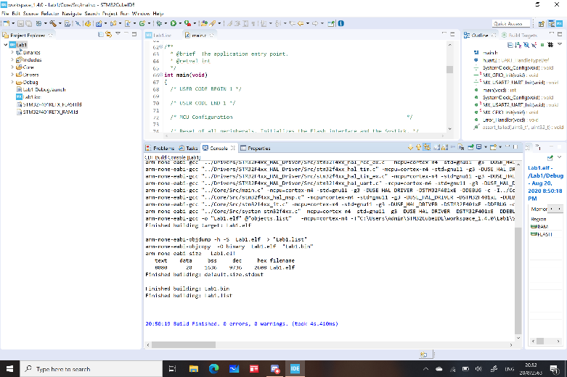compile the program

Compile after using a code

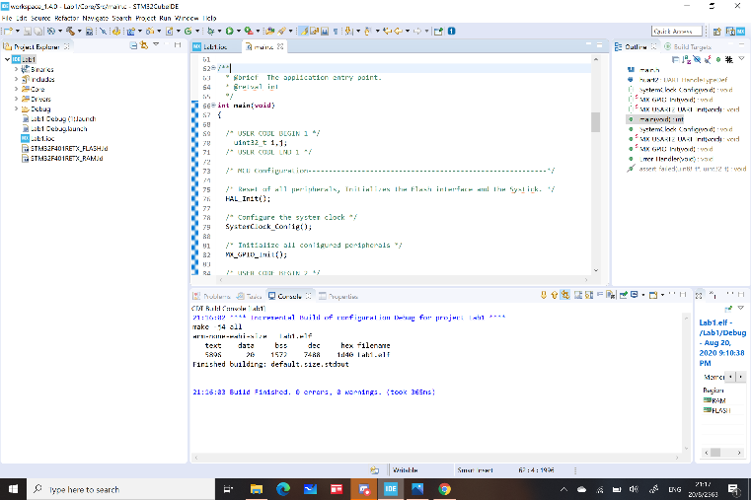

2) the code in main.c

/* USER CODE BEGIN Header */

/**

******************************************************************************

* @file : main.c

* @brief : Main program body

******************************************************************************

* @attention

*

* <h2><center>&copy; Copyright (c) 2020 STMicroelectronics.

* All rights reserved.</center></h2>

*

* This software component is licensed by ST under BSD 3-Clause license,

* the "License"; You may not use this file except in compliance with the

* License. You may obtain a copy of the License at:

* opensource.org/licenses/BSD-3-Clause

*

******************************************************************************

*/

/* USER CODE END Header */

/* Includes ------------------------------------------------------------------*/

**#include** "main.h"

/* Private includes ----------------------------------------------------------*/

/* USER CODE BEGIN Includes */

/* USER CODE END Includes */

/* Private typedef -----------------------------------------------------------*/

/* USER CODE BEGIN PTD */

/* USER CODE END PTD */

/* Private define ------------------------------------------------------------*/

/* USER CODE BEGIN PD */

/* USER CODE END PD */

/* Private macro -------------------------------------------------------------*/

/* USER CODE BEGIN PM */

/* USER CODE END PM */

/* Private variables ---------------------------------------------------------*/

UART_HandleTypeDef huart2;

/* USER CODE BEGIN PV */

/* USER CODE END PV */

/* Private function prototypes -----------------------------------------------*/

**void** **SystemClock_Config**(**void**);

**static** **void** **MX_GPIO_Init**(**void**);

**static** **void** **MX_USART2_UART_Init**(**void**);

/* USER CODE BEGIN PFP */

/* USER CODE END PFP */

/* Private user code ---------------------------------------------------------*/

/* USER CODE BEGIN 0 */

/* USER CODE END 0 */

/**

* @brief The application entry point.

* @retval int

*/

**int** **main**(**void**)

{

/* USER CODE BEGIN 1 */

uint32_t i,j;

/* USER CODE END 1 */

/* MCU Configuration--------------------------------------------------------*/

/* Reset of all peripherals, Initializes the Flash interface and the Systick. */

HAL_Init();

/* USER CODE BEGIN Init */

/* USER CODE END Init */

/* Configure the system clock */

SystemClock_Config();

/* USER CODE BEGIN SysInit */

/* USER CODE END SysInit */

/* Initialize all configured peripherals */

MX_GPIO_Init();

MX_USART2_UART_Init();

/* USER CODE BEGIN 2 */

GPIOB->ODR = 0;

/* USER CODE END 2 */

/* Infinite loop */

/* USER CODE BEGIN WHILE */

**while** (1)

{

/* USER CODE END WHILE */

/* USER CODE BEGIN 3 */

}

/* USER CODE END 3 */

}

/**

* @brief System Clock Configuration

* @retval None

*/

**void** **SystemClock_Config**(**void**)

{

RCC_OscInitTypeDef RCC_OscInitStruct = {0};

RCC_ClkInitTypeDef RCC_ClkInitStruct = {0};

/** Configure the main internal regulator output voltage

*/

__HAL_RCC_PWR_CLK_ENABLE();

__HAL_PWR_VOLTAGESCALING_CONFIG(PWR_REGULATOR_VOLTAGE_SCALE2);

/** Initializes the RCC Oscillators according to the specified parameters

* in the RCC_OscInitTypeDef structure.

*/

RCC_OscInitStruct.OscillatorType = RCC_OSCILLATORTYPE_HSI;

RCC_OscInitStruct.HSIState = RCC_HSI_ON;

RCC_OscInitStruct.HSICalibrationValue = RCC_HSICALIBRATION_DEFAULT;

RCC_OscInitStruct.PLL.PLLState = RCC_PLL_ON;

RCC_OscInitStruct.PLL.PLLSource = RCC_PLLSOURCE_HSI;

RCC_OscInitStruct.PLL.PLLM = 8;

RCC_OscInitStruct.PLL.PLLN = 84;

RCC_OscInitStruct.PLL.PLLP = RCC_PLLP_DIV2;

RCC_OscInitStruct.PLL.PLLQ = 7;

**if** (HAL_RCC_OscConfig(&RCC_OscInitStruct) != *HAL_OK*)

{

Error_Handler();

}

/** Initializes the CPU, AHB and APB buses clocks

*/

RCC_ClkInitStruct.ClockType = RCC_CLOCKTYPE_HCLK|RCC_CLOCKTYPE_SYSCLK

|RCC_CLOCKTYPE_PCLK1|RCC_CLOCKTYPE_PCLK2;

RCC_ClkInitStruct.SYSCLKSource = RCC_SYSCLKSOURCE_PLLCLK;

RCC_ClkInitStruct.AHBCLKDivider = RCC_SYSCLK_DIV1;

RCC_ClkInitStruct.APB1CLKDivider = RCC_HCLK_DIV2;

RCC_ClkInitStruct.APB2CLKDivider = RCC_HCLK_DIV1;

**if** (HAL_RCC_ClockConfig(&RCC_ClkInitStruct, FLASH_LATENCY_2) != *HAL_OK*)

{

Error_Handler();

}

}

/**

* @brief USART2 Initialization Function

* @param None

* @retval None

*/

**static** **void** **MX_USART2_UART_Init**(**void**)

{

/* USER CODE BEGIN USART2_Init 0 */

/* USER CODE END USART2_Init 0 */

/* USER CODE BEGIN USART2_Init 1 */

/* USER CODE END USART2_Init 1 */

huart2.Instance = USART2;

huart2.Init.BaudRate = 115200;

huart2.Init.WordLength = UART_WORDLENGTH_8B;

huart2.Init.StopBits = UART_STOPBITS_1;

huart2.Init.Parity = UART_PARITY_NONE;

huart2.Init.Mode = UART_MODE_TX_RX;

huart2.Init.HwFlowCtl = UART_HWCONTROL_NONE;

huart2.Init.OverSampling = UART_OVERSAMPLING_16;

**if** (HAL_UART_Init(&huart2) != *HAL_OK*)

{

Error_Handler();

}

/* USER CODE BEGIN USART2_Init 2 */

/* USER CODE END USART2_Init 2 */

}

/**

* @brief GPIO Initialization Function

* @param None

* @retval None

*/

**static** **void** **MX_GPIO_Init**(**void**)

{

GPIO_InitTypeDef GPIO_InitStruct = {0};

/* GPIO Ports Clock Enable */

__HAL_RCC_GPIOC_CLK_ENABLE();

__HAL_RCC_GPIOH_CLK_ENABLE();

__HAL_RCC_GPIOA_CLK_ENABLE();

__HAL_RCC_GPIOB_CLK_ENABLE();

/*Configure GPIO pin Output Level */

HAL_GPIO_WritePin(LD2_GPIO_Port, LD2_Pin, *GPIO_PIN_RESET*);

/*Configure GPIO pin : B1_Pin */

GPIO_InitStruct.Pin = B1_Pin;

GPIO_InitStruct.Mode = GPIO_MODE_IT_FALLING;

GPIO_InitStruct.Pull = GPIO_NOPULL;

HAL_GPIO_Init(B1_GPIO_Port, &GPIO_InitStruct);

/*Configure GPIO pin : LD2_Pin */

GPIO_InitStruct.Pin = LD2_Pin;

GPIO_InitStruct.Mode = GPIO_MODE_OUTPUT_PP;

GPIO_InitStruct.Pull = GPIO_NOPULL;

GPIO_InitStruct.Speed = GPIO_SPEED_FREQ_LOW;

HAL_GPIO_Init(LD2_GPIO_Port, &GPIO_InitStruct);

}

/* USER CODE BEGIN 4 */

/* USER CODE END 4 */

/**

* @brief This function is executed in case of error occurrence.

* @retval None

*/

**void** **Error_Handler**(**void**)

{

/* USER CODE BEGIN Error_Handler_Debug */

/* User can add his own implementation to report the HAL error return state */

/* USER CODE END Error_Handler_Debug */

}

**#ifdef** USE_FULL_ASSERT

/**

* @brief Reports the name of the source file and the source line number

* where the assert_param error has occurred.

* @param file: pointer to the source file name

* @param line: assert_param error line source number

* @retval None

*/

**void** assert_failed(uint8_t *file, uint32_t line)

{

/* USER CODE BEGIN 6 */

/* User can add his own implementation to report the file name and line number,

tex: printf("Wrong parameters value: file %s on line %d\r\n", file, line) */

/* USER CODE END 6 */

}

**#endif** /* USE_FULL_ASSERT */

/************************ (C) COPYRIGHT STMicroelectronics *****END OF FILE****/

We have to consider the value of MODER and OCR since it has the information of the register. While we are in the debug mode the program will run line by line. So we run it line by line and take note of it when the MODER and OCR change value.

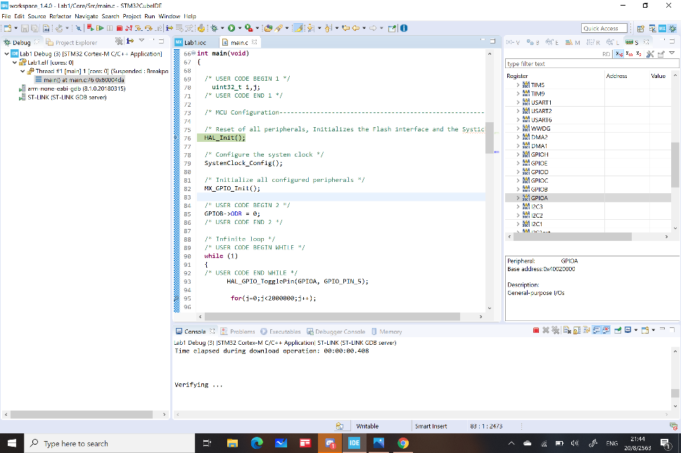

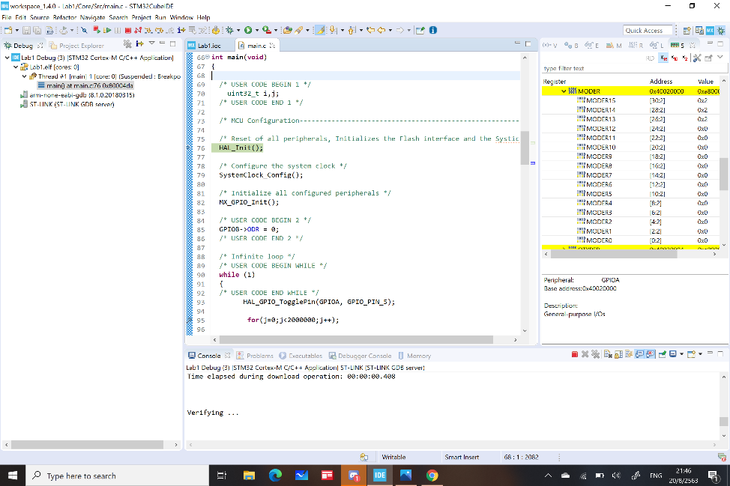

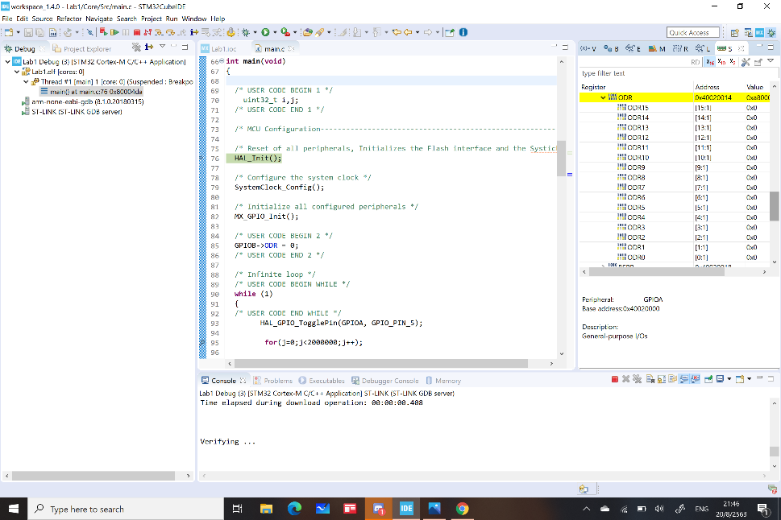

3) Open a “Lab1.ioc”, then change the clock so that it is 4 times speed of the previous one.

4 times of 25MHz is 100MHz which exceed the maximum possible clock frequency, I change it to 84 MHz instead.

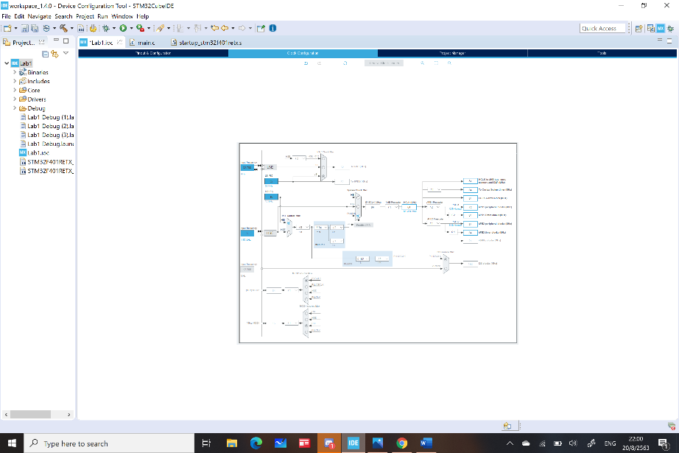

Then recompile the project ( Project -> Build All) . Then upload and run the program again.

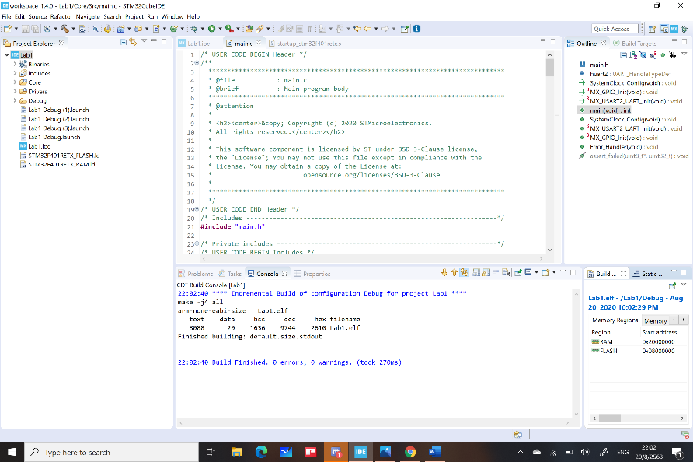

The picture of the board

